# Milestone 3

In this milestone, we are required to focus on the scheduling and design.

* Showcase our overall **project’s schedule.**
* Display the schedule of our **sprints/iterations**, the **timings** of our scrum meetings, etc.
* Mention and explain the **Project Management Tool** used.
* Describe the **component designs** of our system.
* Display a **class diagram** to describe the software design
* Give Proof Of Concept with **MoMs of our scrum meetings**.

## Project Management

### Sprint Schedule

* Below is a table to describe our sprints

| **Scrum Iterations/Sprints** | **Start Date** | **End Date** | **Status** | **Notes** |
| --- | --- | --- | --- | --- |
| Milestone 1 | Jun 6, 2024 | Jun 16, 2024 | Completed | Identify User Requirements |
| Milestone 2 | Jun 18, 2024 | Jun 30, 2024 | Completed | User Interfaces |
| Milestone 3 | Jul 1, 2024 | Jul 10, 2024 | In progress | Scheduling and Design |
| Milestone 4 | Jul 10, 2024 | Jul 28, 2024 | Not started | API Endpoints |
| Milestone 5 | Jul 28, 2024 | Aug 7, 2024 | Not started | Test cases, test suite of the project |
| Milestone 6 | Aug 7, 2024 | Aug 18, 2024 | Not started | Final Submission pdf |

### Scrum Meetings

* We discuss our work on a daily basis on a whatsapp group that we have created.
* A stand-up meeting is scheduled every Monday and Friday (twice a week) scheduled at 10:00 PM.
* We sometimes change the timings according to the team’s comfort

### Scrum Meetings Notes - MoMs

**Need to add a few MoMs**

### Project Management Tool

We use **JIRA** as our project management tool.

Link to Jira platform: <https://se-may-24-iitm-bs-team15.atlassian.net/>

We use Jira to achieve the following:

* Keep track of the sprints
* Create issues and tickets for each member’s task
* Collaborate on code to keep track of the commits on github
  + We connected our Jira with github to get data on code commits, pull requests, etc.

Below are a few screenshots of the Jira platform used by our team, as a proof of concept.

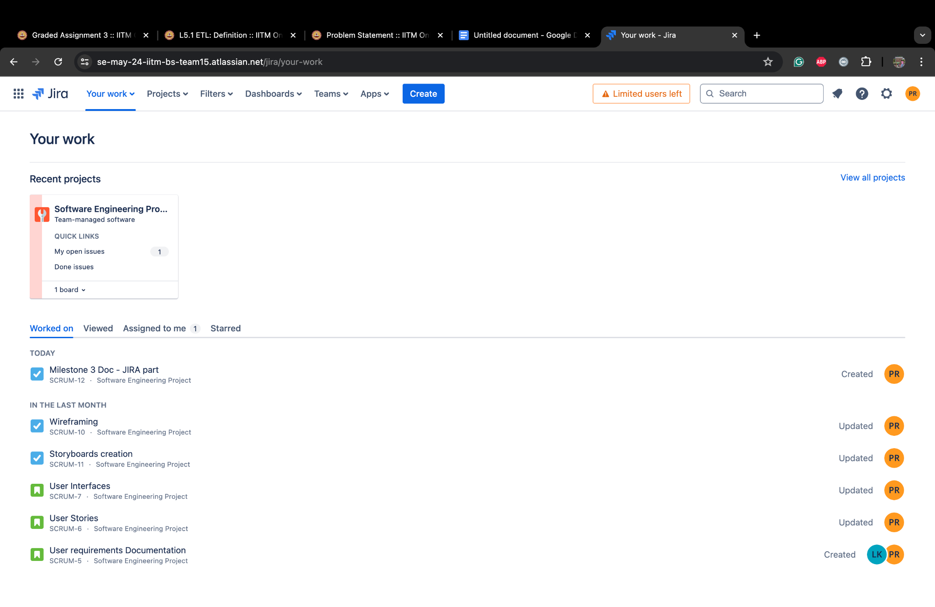

Jira: Home page for members

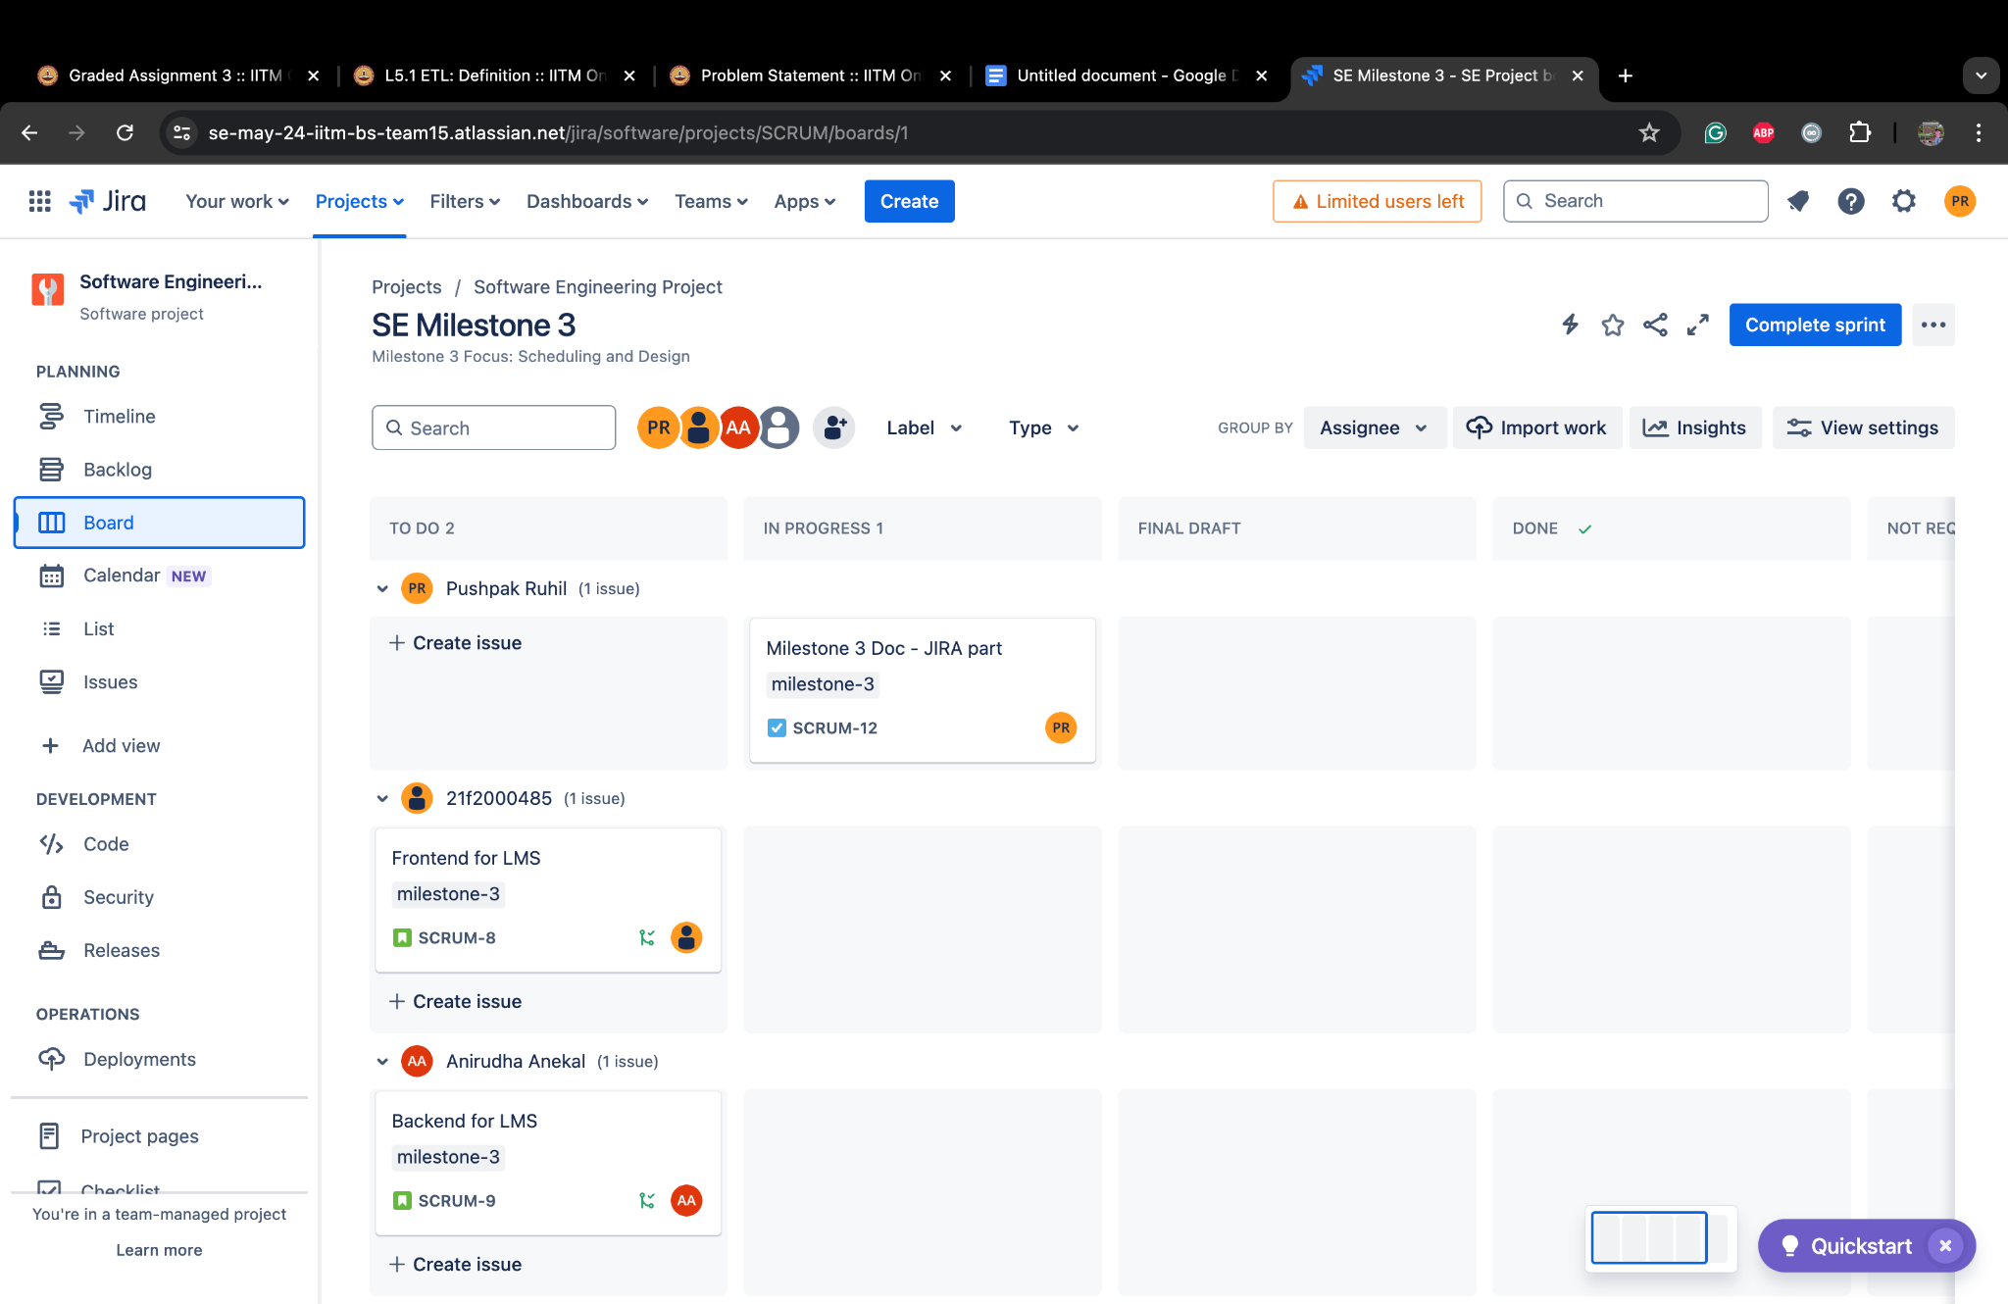

Jira: Current sprint board

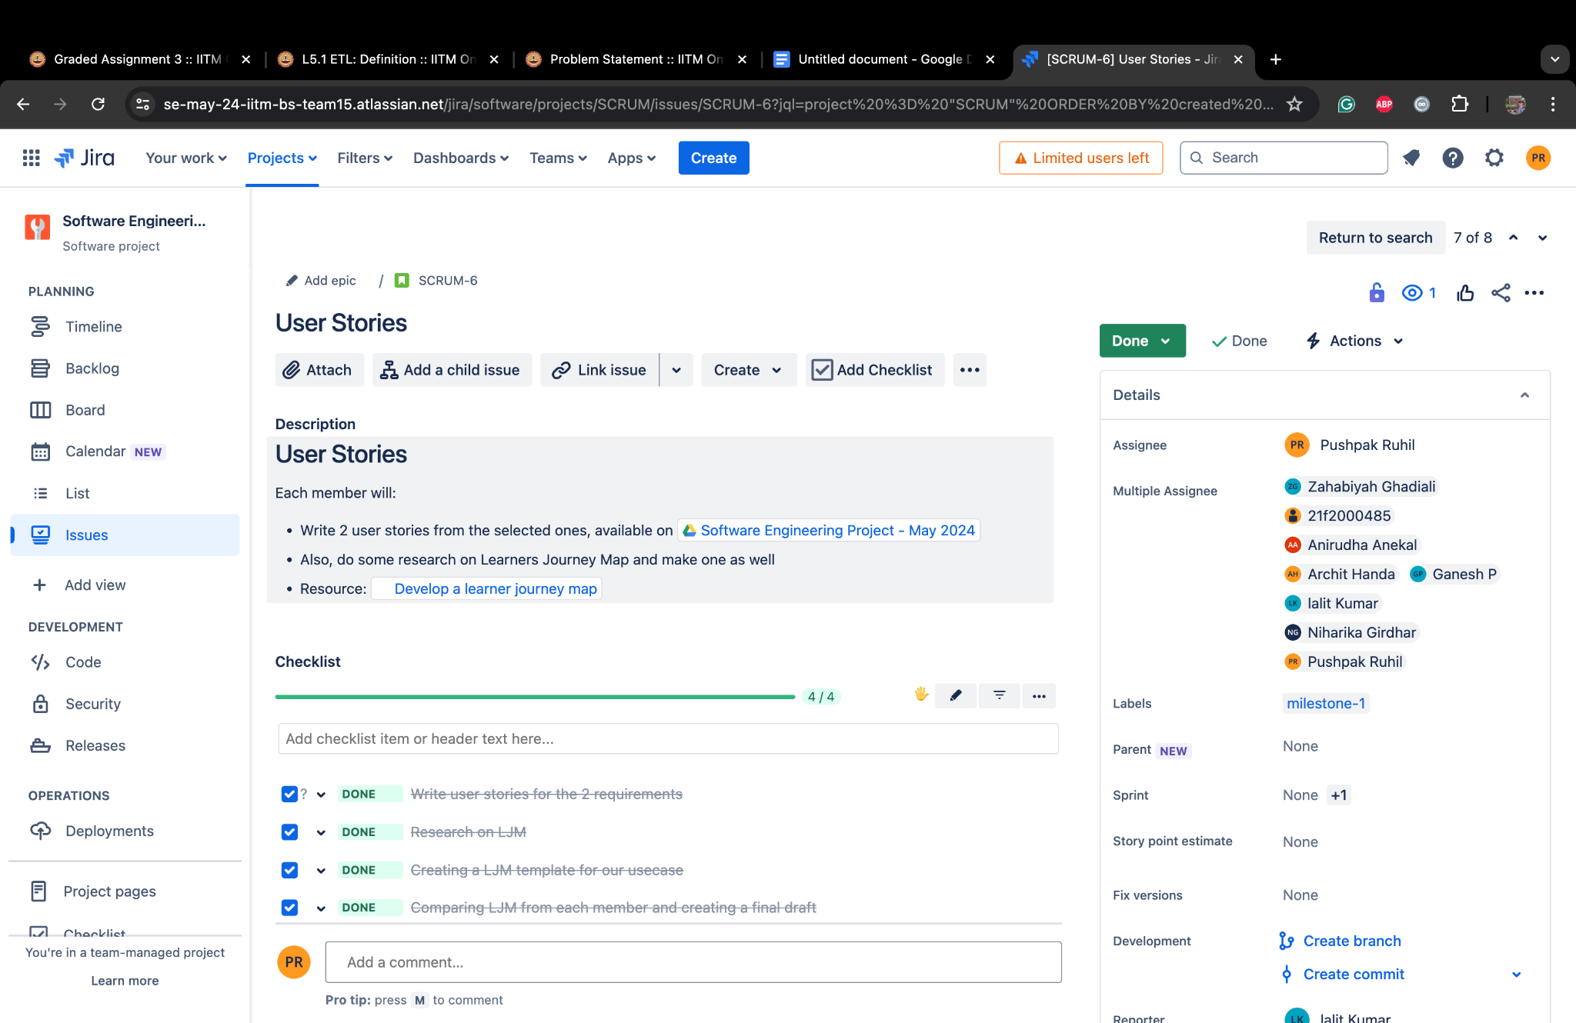

Jira: Issue ticket created

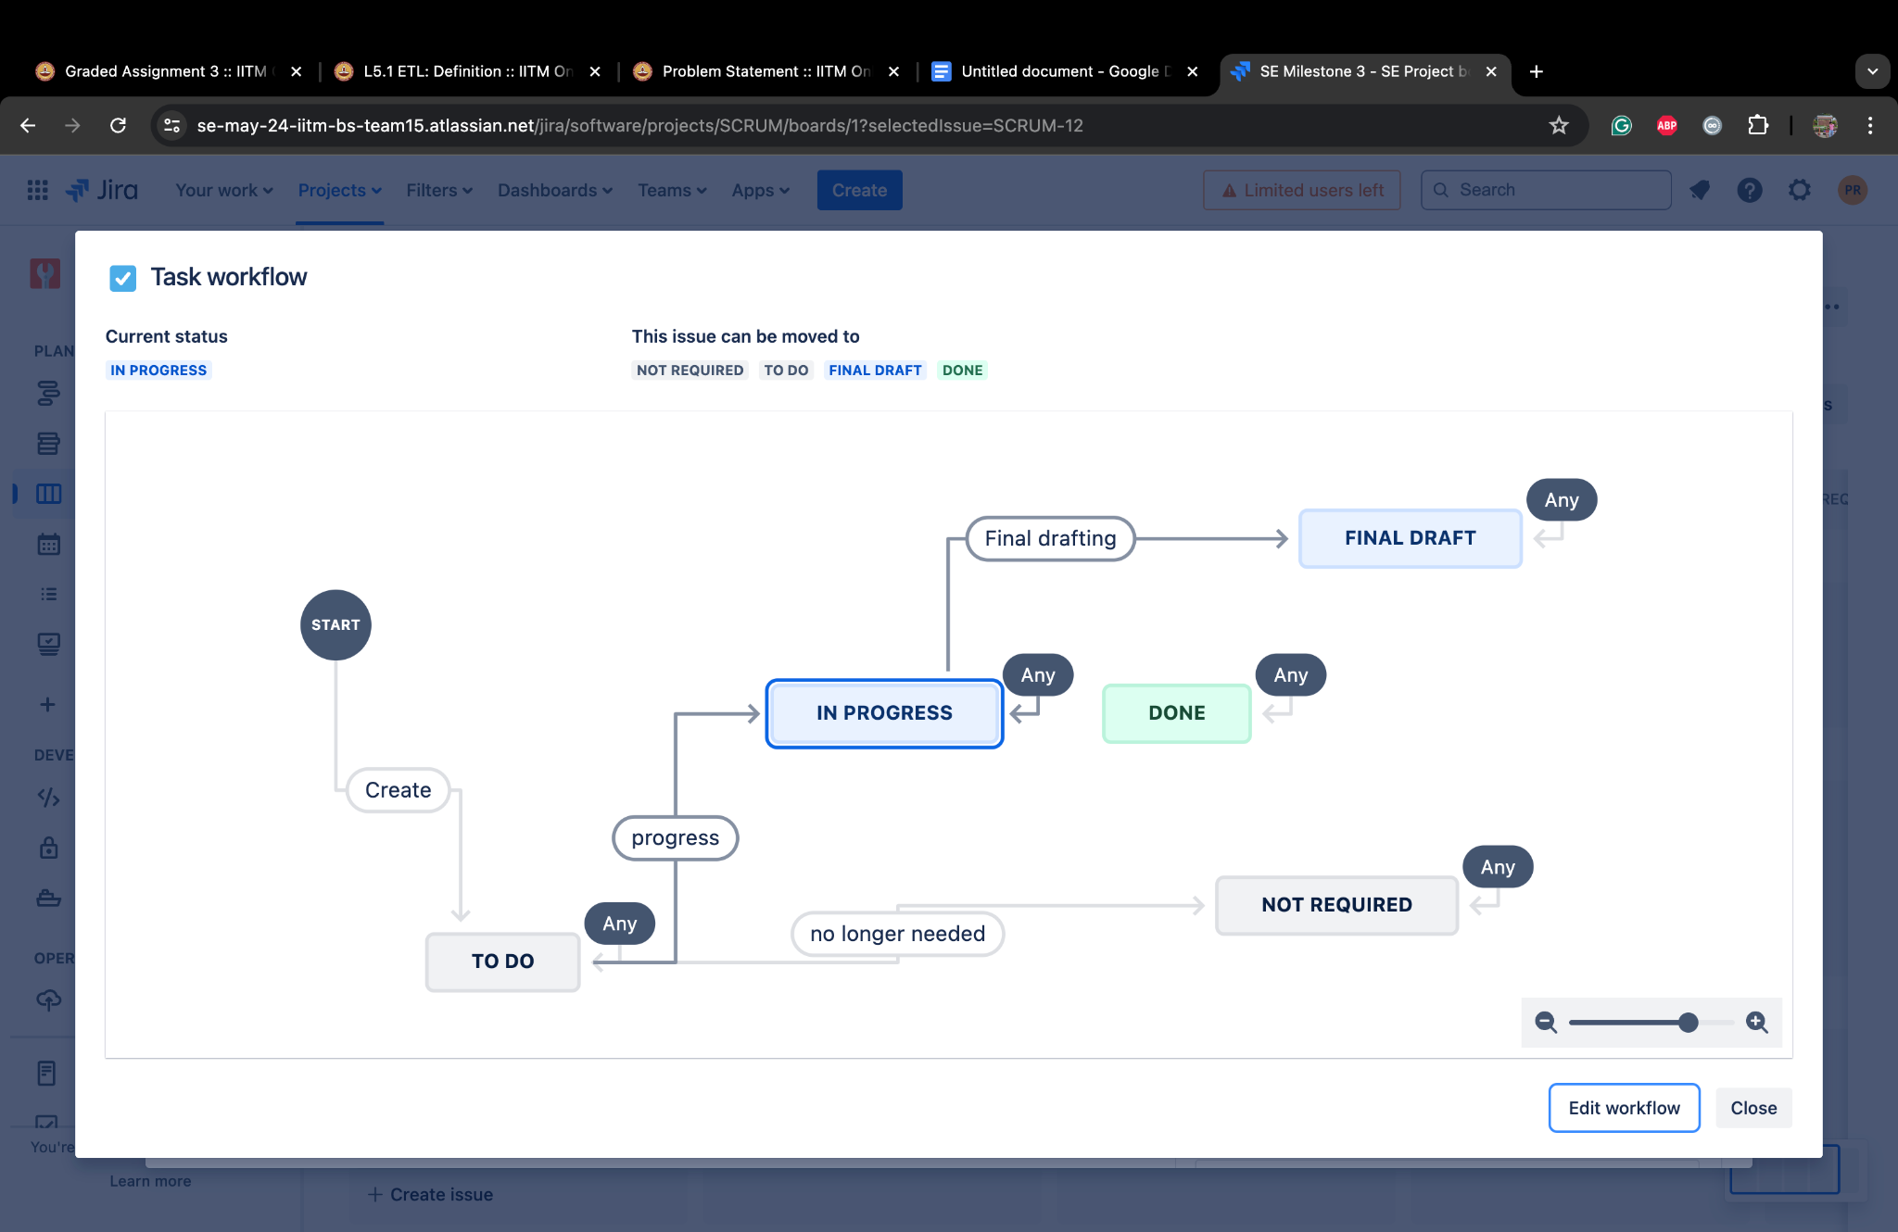

Jira: Workflow for epics, stories, tasks and subtasks